**REPORT**

**Bank Marketing Campaign Analysis**

**1. Introduction**

The dataset is from a Portuguese banking institution’s marketing campaign. The bank conducted telemarketing calls to promote term deposits to customers. Each record in the dataset represents details about a customer and the outcome of the contact, stored in the "deposit" column (whether the customer subscribed to a term deposit: **yes** or **no**).

**2. Objectives**

Key business questions addressed in this analysis:

* What is the age distribution of customers?
* Which marital status group is most common?
* Which education level is most common?
* How does the subscription rate vary by education and marital status?
* What percentage of customers subscribed to the term deposit?
* Which contact communication type has the highest success rate?
* Which month had the highest conversion rate?
* How does call duration impact subscription likelihood?
* Does account balance influence subscription probability?
* Are customers with housing or personal loans more or less likely to subscribe?
* How does previous campaign outcome affect current subscription rates?

**3. Data Overview**

* **Rows:** ~45,000 records
* **Columns:** ~17 features including:
  + **Demographics:** age, marital, education
  + **Financial:** balance, housing, loan
  + **Campaign-related:** contact type, month, duration, previous outcome, number of contacts
  + **Target Variable:** deposit (**yes** / **no**)
* **Data Types:** mixture of numerical (e.g., age, balance, duration) and categorical (e.g., marital, education, contact, month)

**4. Methodology**

* **Tools Used:**
  + **Python (pandas, matplotlib, seaborn)** for data cleaning, EDA, and visualizations
  + **SQL** for querying and filtering customer segments
  + **Power BI** for creating interactive dashboards

**5. Analysis & Insights**

* Most customers are aged between **30–40 years**.
* **Married** customers form the largest group.
* **Secondary** education is the most common.
* Subscription rate varies significantly across education and marital status — **single and higher-educated customers** have higher conversion rates.
* **Only ~11–12%** of customers subscribed overall.
* **Cellular** contact type has a much higher success rate than telephone.
* **May** is the busiest month, but **March** and **September** have better conversion rates.
* Longer call duration strongly correlates with subscription likelihood.
* Customers with **higher balances** are more likely to subscribe.
* Customers **without housing loans** are slightly more likely to subscribe.
* A **previous successful campaign outcome** greatly increases current conversion rates.

**6. Visualization** 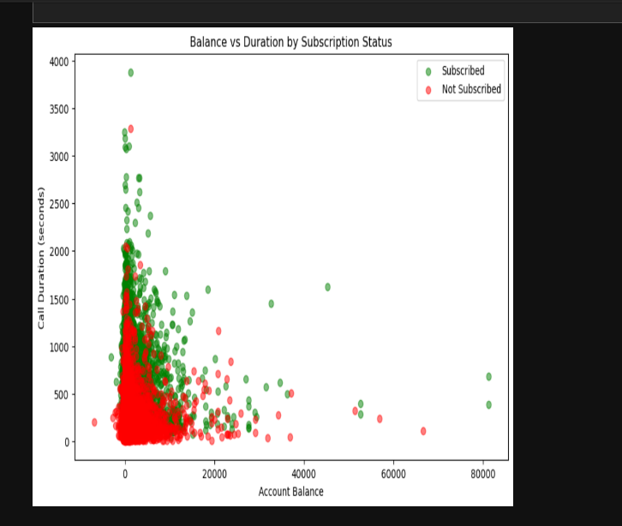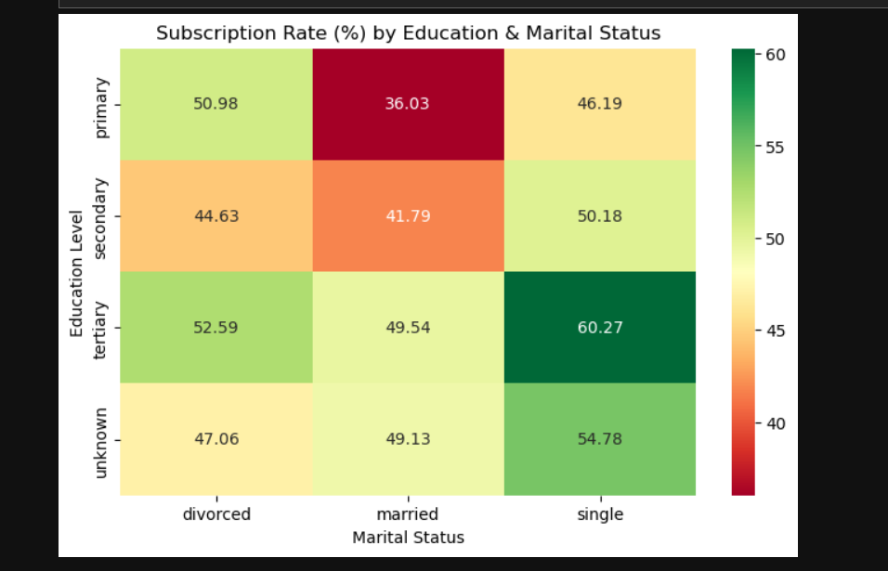   
Examples:

* Bar chart: Subscription rate by education level
* Line chart: Monthly subscription trend
* Heatmap: Correlation between numerical variables
* Pie chart: Distribution of contact types
* Scatter Chart: Balance vs Duration By Subscription rate
* **Dashboard**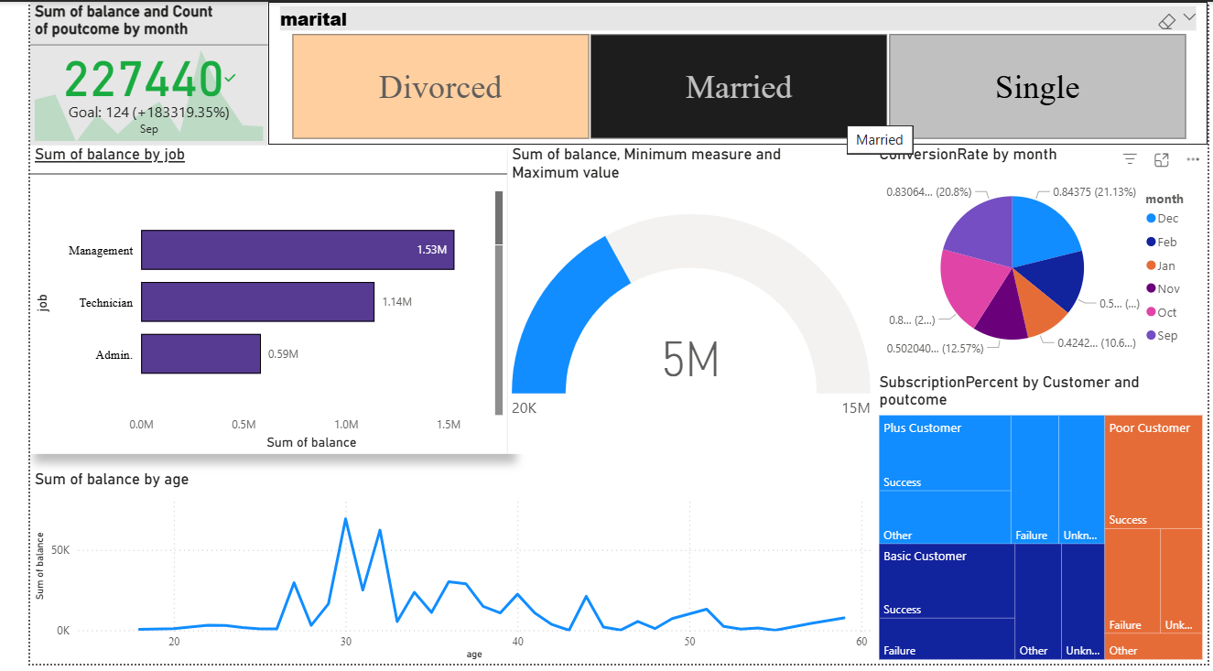

**7. Conclusion & Recommendations**

* Focus marketing efforts on **single, higher-educated customers with higher balances**.
* Prioritize **cellular contact** over telephone for better results.
* Invest more in **months with high conversion rates** (e.g., March, September).
* Keep call duration longer when interest is detected, as it increases likelihood of conversion.
* Follow up with customers who had **previous successful campaign interactions** — they are high-potential leads.